SAILING INSTRUCTIONS
ATTACHMENT A
RACE AREA, MARKS & COURSES
- The Race Area
The race area will be the Western Solent.
- Starting Marks and Starting Line
  - The starting line marks will be:
Starting Line | Inner Mark | Inner Limit Mark  (if laid) | Outer Mark
Committee Boat | Staff with orange flag on Committee Boat | Pink button | Orange buoy with black & white chequers
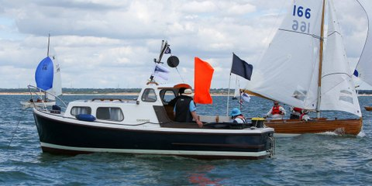
The approximate location of the Committee Boat will be announced by VHF. The committee boat will probably be the 21ft Nelson-type launch Chinook – blue hull with white deckhouse.
  - The starting line will be between the course side of the inner and outer starting marks. The Committee Boat may be at either end of the line.
  - The inner limit mark is a starting mark, and shall have the same required side as the Committee Boat.
  - Before a boat’s first start of each day she shall pass the Committee Boat so that her sail number is clearly visible to the Race Committee.
- Marks of the Course
  - The list of marks is available on the Royal Lymington club website at:
    - Inshore racing marks here
    - West Solent Chart 2021 here
  - In addition a large orange inflatable mark may be laid, probably but not necessarily as the first mark.
  - The course to be sailed, the marks to be used, the side on which left and the order of rounding or passing may be displayed on a board across the stern of the committee boat or may be announced on VHF or both.
  - All marks will be rounding marks unless its designator has an orange bar below or it is announced as a passing mark on VHF.
  - Marks with designators on a red background shall be rounded or passed to port. Marks with designators on a green background shall be rounded or passed to starboard.
  - When the moveable mark is used, the approximate position will be displayed near the course board at the start or if course boards are not being used will be announced on VHF as part of the course announcement.

- Finishing Marks and Finishing Line
  - The finishing line will be between a committee boat and the final mark designated in the course display or read-out.
- Obstructions – not used
- Shortening the Course
A6.1. In addition to RRS 32. When a Race Committee boat near a designated mark of the course is displaying flag S over H with repetitive sound signals, that mark and the committee boat shall become a gate. This may change the required side of the mark. Boats shall pass through the gate in accordance with RRS 28.2(c) and sail directly to the Finish, complying with Sailing Instruction A5.

